Abstract letter Design Project Unit:
Objectives:
* develop deeper understanding of color theory
* develop & demonstrate understanding of typography
* utilize graphic design composition
* acrylic painting technique
* develop & express an idea from sketch to a final artwork

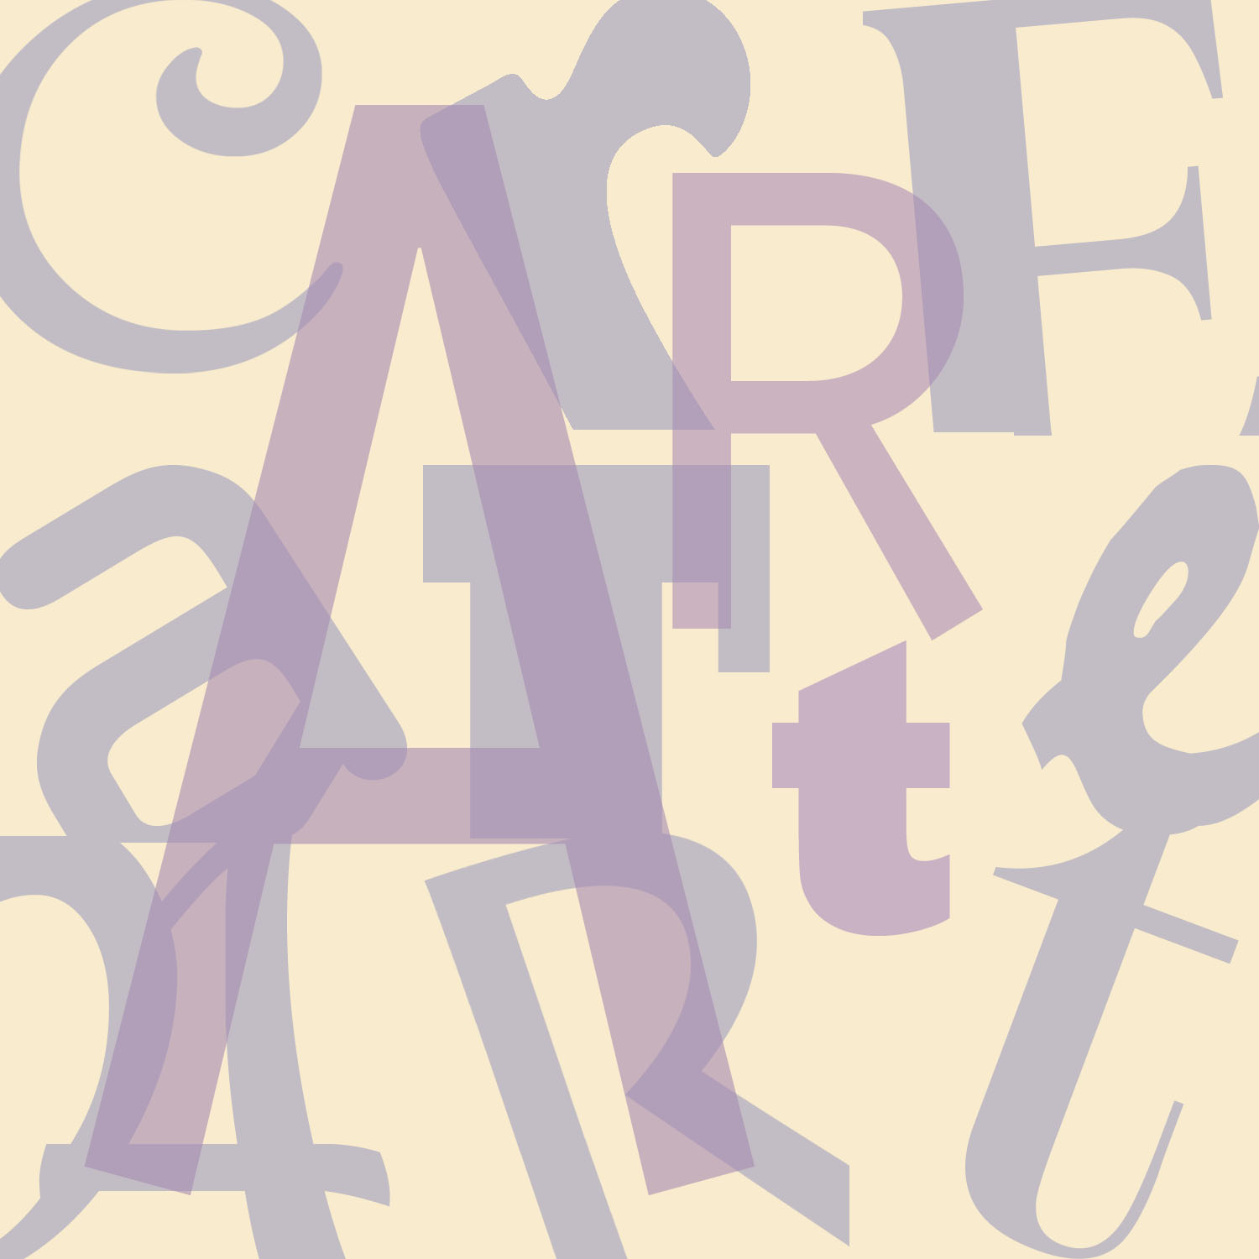

Lesson #1: Review color theory- question & answer . Learning Strategy: random # answers question. Materials: color wheels
Lesson #2: Color schemes worksheet. Materials: colored pencils, color wheels
Lesson#3: Understanding Typography. Typography video (youtube). I shot the serif game. Materials: MacLab
Lesson #4: Graphic Design Layout: grid , unity, variety, composition. Learning strategy: small group choose & analyze magazine design. Random share. Materials; Design magazines
Lesson #5: Letter design – serif & sans serif designs within a square.- nine different thumbnails. Could be based on phrase based on 2 or three words. Materials: paper & pencil
Lesson #6: Create composition rough draft with nine square & overlapping larger letters for emphasis. Develop color scheme. Materials: Paper & pencils
Lesson #7: Enlarge rough draft to final 12 x 12” & sketch out using rulers & drafting tools.
Lesson#8: Learn & show differences in brushes. Technique & setup/cleanup procedures
Lesson #9: Paint mixing demo & paint entire composition.
Lesson#10: final assessment

